**Transport Layer Security (TLS) Lab**

**Task1:TLS Client**

**Task 1.a: TLS handshake**

Use the following code, in order to print out the various algorithms used by TLS, you can add the pprint.pprint(ssock.cipher()) statement on the basis of the experimental manual code:

*#!/usr/bin/python3*

*import socket, ssl, sys, pprint*

*hostname = sys.argv[1]*

*port = 443*

*cadir = '/etc/ssl/certs'*

*# Set up the TLS context*

*context = ssl.SSLContext(ssl.PROTOCOL_TLSv1_2)*

***For Ubuntu 16.04 VM***

*context.load_verify_locations(capath=cadir)*

*context.verify_mode = ssl.CERT_REQUIRED*

*context.check_hostname = True*

*# Create TCP connection*

*sock = socket.socket(socket.AF_INET, socket.SOCK_STREAM)*

*sock.connect((hostname, port))*

*input("After making TCP connection. Press any key to continue ...")*

*# Add the TLS*

*ssock = context.wrap_socket(sock, server_hostname=hostname,*

*do_handshake_on_connect=False)*

*ssock.do_handshake() # Start the handshake*

*print("=== Cipher used: {}".format(ssock.cipher()))*

*print("=== Server hostname: {}".format(ssock.server_hostname))*

*print("=== Server certificate:")*

*pprint.pprint(ssock.getpeercert())*

*pprint.pprint(context.get_ca_certs())*

*input("After TLS handshake. Press any key to continue ...")*

*# Close the TLS Connection*

*ssock.shutdown(socket.SHUT_RDWR)*

*ssock.close()*

TLS requires four steps to provide secure communication for sockets.

* The first step is to create a TLS context object. The object saves our preference settings for certificate authentication and encryption algorithm selection. The context part of the code.
* The second step is to establish a TCP handshake protocol, make a TCP connection, and the code sock part.
* The third step is to call the context object created in the first step and use the wrap_socket() method on it, which means that the OpenSLL library is responsible for controlling our TCP connection. Then exchange the necessary handshake information with the communicating party and establish an encrypted link. The ssock =context.wrap_socket... part of the code
* The last step is to use the ssl_sock object returned by the wrap_socket() call for all subsequent communications. Subsequent communication needs to use a format similar to ssock.method name.

**Question**

1. **print out**

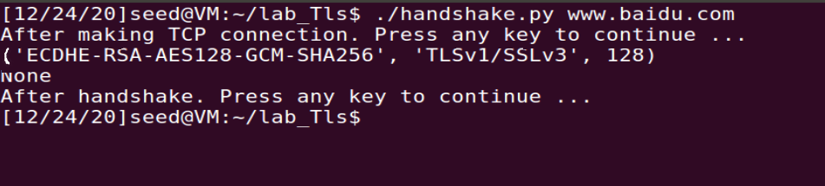

That is ECDHE-RSA-AES128-GCM-SHA256, the meaning of each parameter is as follows:

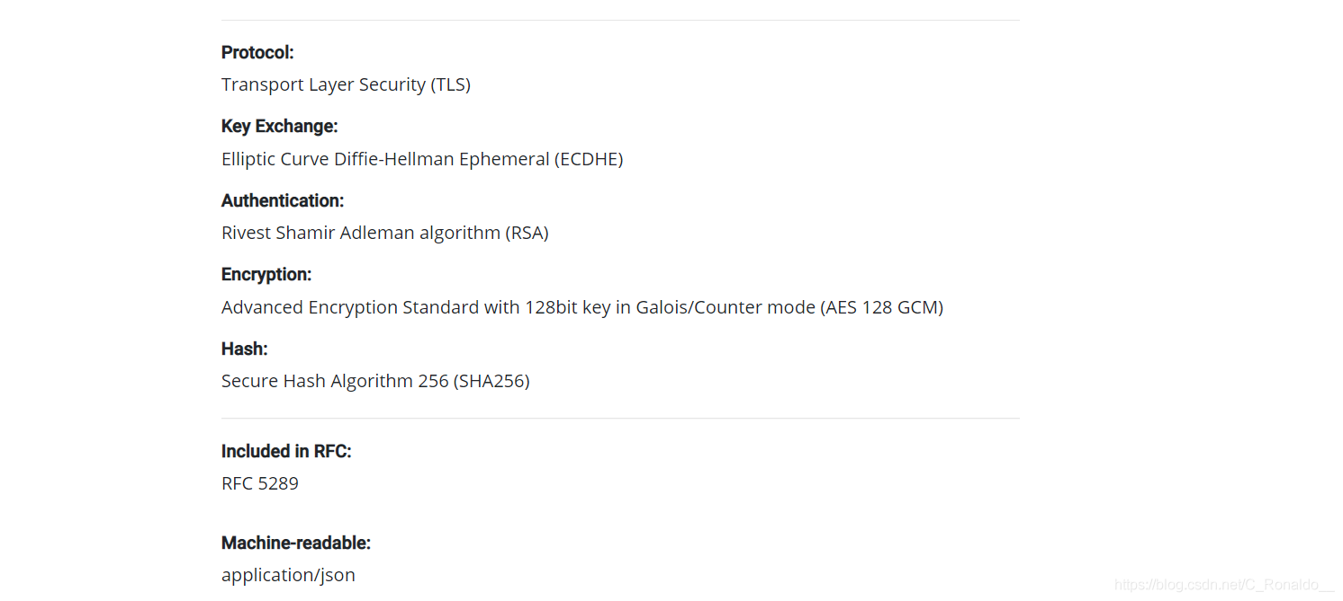

That is, use the AES128-GCM algorithm for encrypted communication

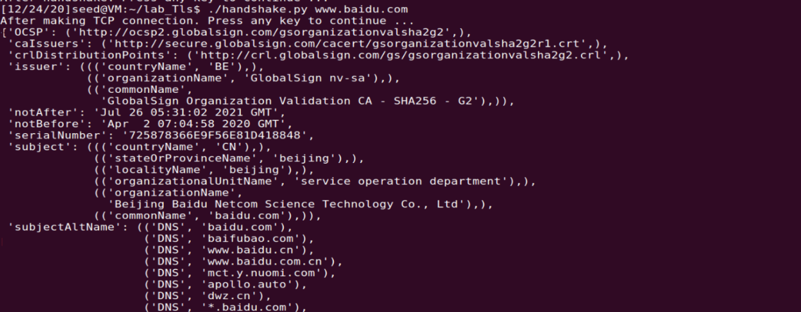

1. **Store many certificate files:**

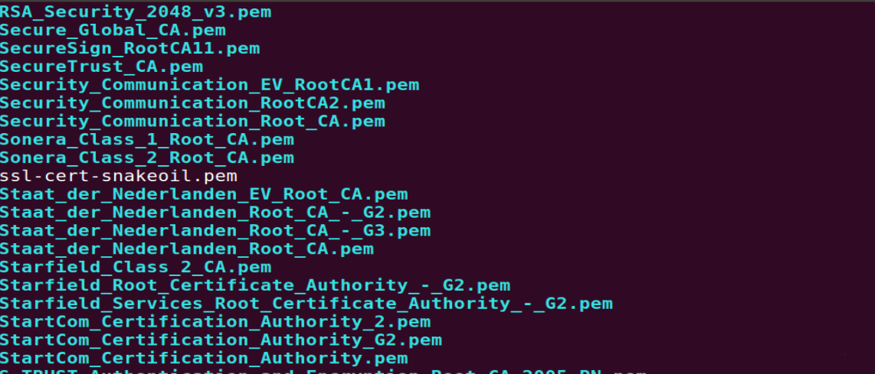

These files are root CA files, which are used to verify the validity of the certificate sent back by the server when establishing a TLS connection.

1. Use wireshark to capture relevant information about the TLS connection with www.baidu.com, get a series of data packets, and analyze them one by one:

* **TCP handshake:**

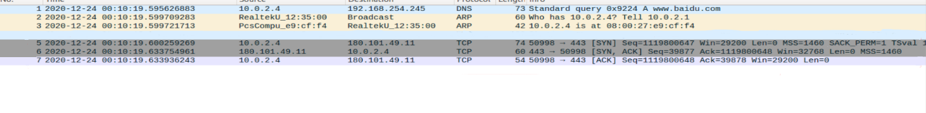

The TCP three-way handshake protocol, it can be seen that the first TCP handshake is intuitive. TLS is based on the transport layer, so it should be based on the TCP connection. Of course, there are also based on UDP, called DTLS. .

* **TLS handshake**

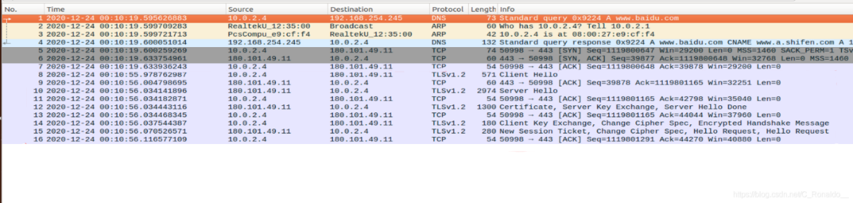

The TLS packets in the picture are all TLS handshake related data packets. The following analysis is one by one:

* The client first sends out Client Hello related data, including all cipher suites supported by the client, client random numbers (used as Nonce), uh... a lot of information

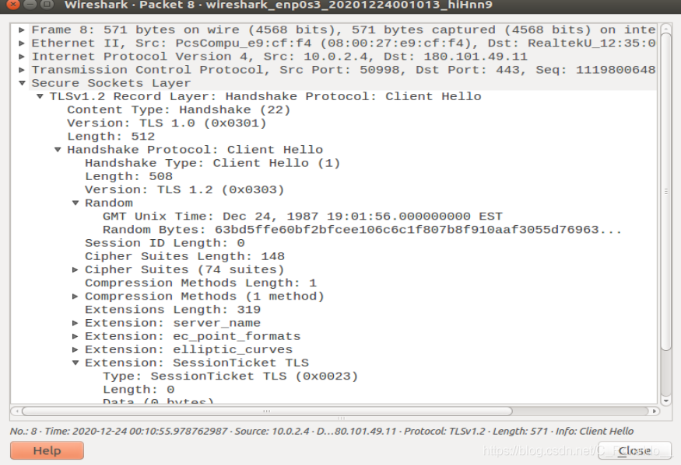

* The server replies to the client Server Hello related data:

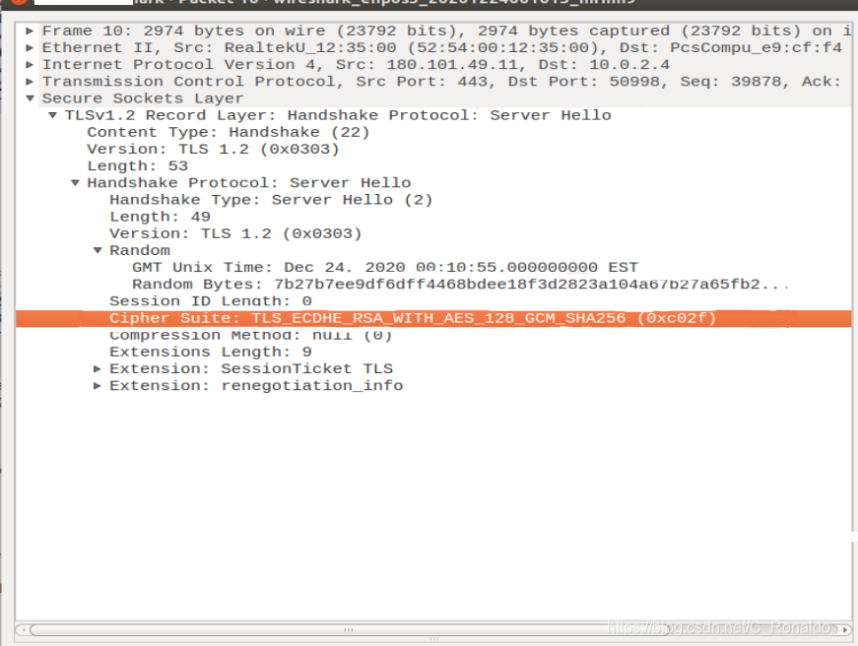

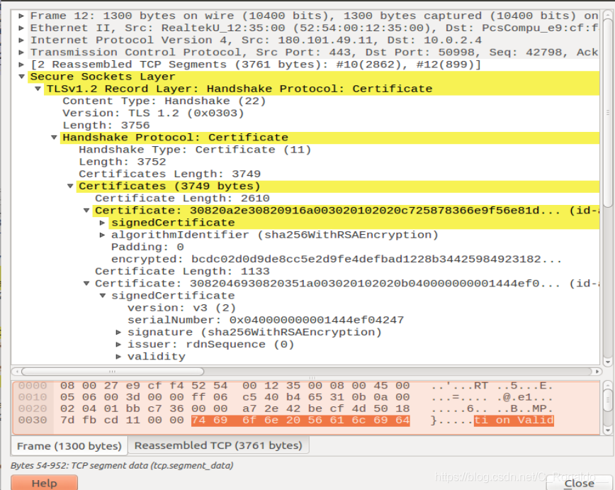And the certificate (maybe the amount of certificate data is too large, it will be transmitted separately from the above):

* Subsequently, the client verifies the validity of the certificate. If it is valid, the client sends a Key Exchange Client Key Exchange and a Change Cipher Spec (change cipher specification message) to the server, and the client handshake ends:

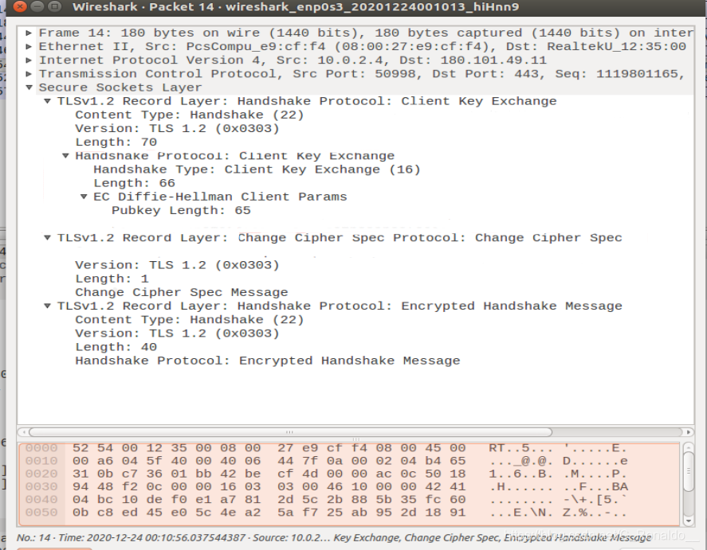

* The server replies to Change Cipher Spec (change cipher specification message) and a New Session value, and the handshake ends. Sometimes these two will be sent separately, that is, they may not be sent together:

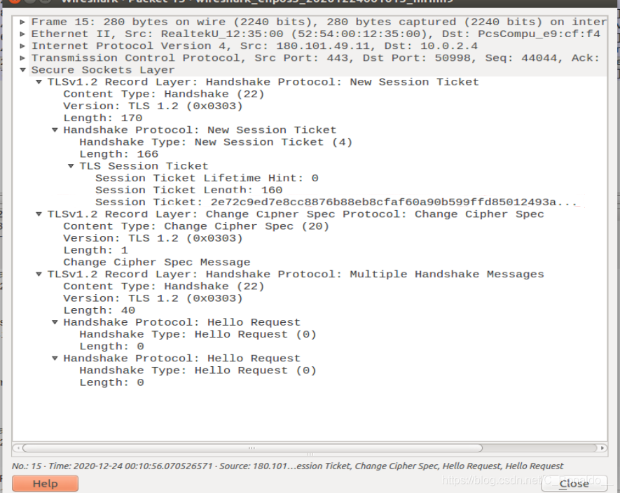

**Task 1.b: CA’s Certificate**

This experiment took me a long time... I took a big detour...

First write the correct experimental ideas and process:

According to the experimental requirements, two URLs need to be selected for testing:

Destination URL: [www.baidu.com](http://www.baidu.com):

1. In the above task, we print out the information of the certificate sent back by the server and find the issuer information in the certificate information:

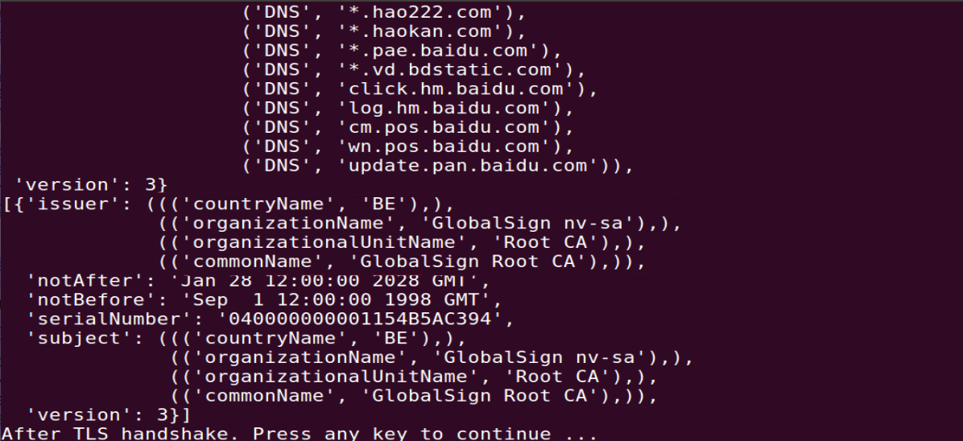

1. Go to the /etc/ssl/certs directory to find the .pem file that matches the organizationalUnitName field or commonName field of the certificate sent back by the server. As for when to choose which field, I don't know what is needed when testing www.baidu.com The commonName field of the file corresponds to the GlobalSign_Root_CA.pem file in the /etc/ssl/certs directory, and in the subsequent www.jd.com test, we found that the file matching the organizationalUnitName field information is valid... As for the specific matching mechanism , I don’t know...On this point, I took a lot of detours. Finally...
2. Copy the GlobalSign_Root_CA.pem file in the /etc/ssl/certs directory to the newly created ./certs folder in the experiment directory, and use the corresponding command to generate the hash value of the file and perform the soft link operation to obtain the following effect:

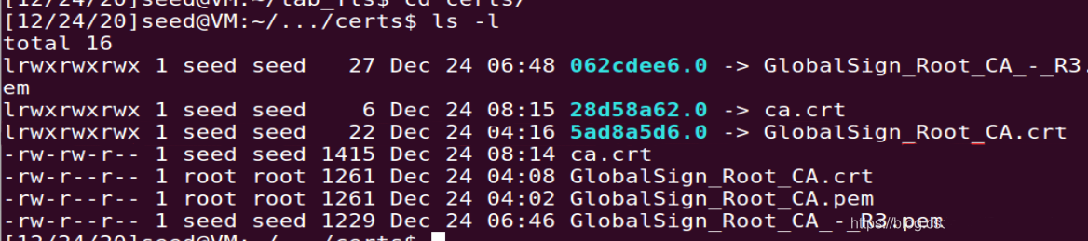

1. Subsequently, modify the cadir=’./certs’ in the previous code to test and find that the results are consistent, so task1a is the same, the results can print out the corresponding information of the certificate, and the connection is successful.

**Destination URL: www.jd.com**

We originally planned to test www.alibaba.com, but since the verification certificate corresponding to the certificate of this website is the same as the .pem file of the www.baidu.com file, we changed a website with a different certificate to test and use Jingdong.

Direct test, because ./cert is not configured with the corresponding certificate, I get the error message:

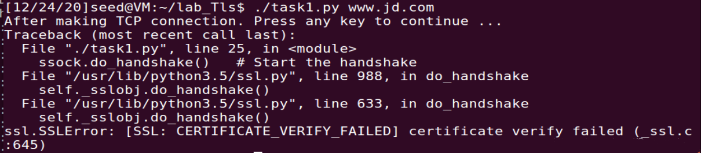

At this point, modify cadir=’./certs’ in the code as the host storage certificate directory: cadir=‘etc/ssl/certs’ to get the corresponding certificate issuer information:

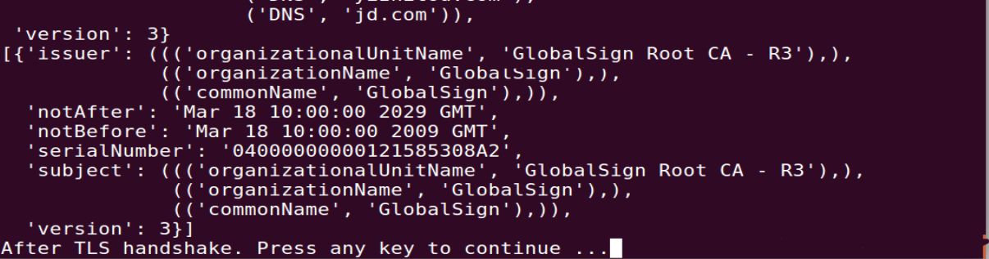

Find the corresponding .pem file in the etc/ssl/certs directory, move it to the ./cert file, perform hash calculation, soft link processing, and then change back to cadir='./certs' to get the correct return result ,connection succeeded.

Summary of problem-oriented thinking

**Question 1:**

According to the experimental requirements, we need to find the corresponding certificate file in the /etc/ssl/certs directory to verify the certificate returned by the server, but how to find the correct .pem file?

In response to this problem, the first thing that comes to mind is to look for the .pem field information in the server certificate printed by the code. However, the .pem format field did not appear in the certificate field, so I wondered: Is there any function or method in the ssl library that can print out the name of the .pem file that needs to be matched, so a search...Look at the ssl source code, Although I didn’t understand much, I still didn’t find anything usable. After spending a long time, forget it, and don’t find it, I tried to find a few names and the subject field in the certificate in the etc/ssl/certs directory. I found several certificate files with the best match, but the GlobalSign_Root_CA.pem file looks the best match. I tried it, hey. . . Okay

* Maybe there is no such method. . . The certificate file name directly matches the hash value. . . I split...

**Question 2:**

In the experiment manual, all the .crt files are manipulated, and the .pem files in the etc/ssl/certs directory are all .pem files, this...can it be successful? What is the difference between the two files?

According to the soft link, two files with the same file name and different suffixes were found. These two files were originally linked to each other. You can find them using the ls -l command in the etc/ssl/certs directory and move them to the experiment folder.

Use the diff command to compare and find that the file content is the same:



Access to information: .pem is a file in a specific format encoded by BASE64. There are fixed strings at the beginning and end of the file, such as -BEGIN-... and .crt files are common in UNIX systems, and most of them are files in PEM format.

So the two are basically equal,

The hash value generated by using the two file names is also the same, and both can be verified by the certificate

…Bingo!

**Task 1.c**

Test the www.sdu.edu.cn website, and perform the following sub-case tests after configuring /etc/hosts:

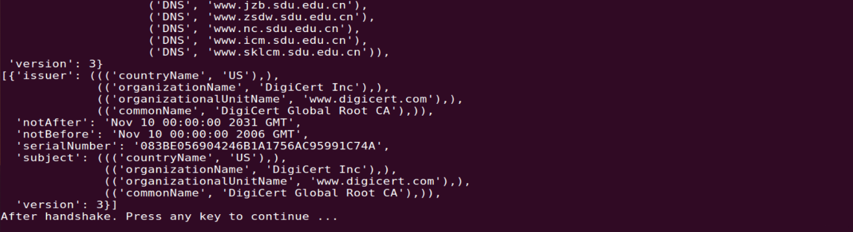False: No hostname verification is performed, and the wrong certificate can be verified successfully.

True: Perform host name verification, and the wrong certificate cannot be verified successfully.

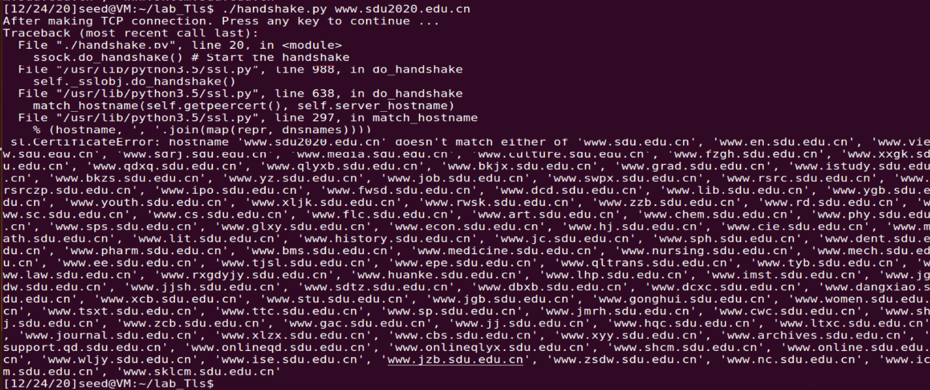

**Question:**

If hostname verification is not performed, then the attacker can use the legitimate certificate of other websites to impersonate the legitimate certificate of his forged website and send it back to the user for verification. Since the hostname verification is ignored, the user will not notice it. Achieve the website's purpose of deceiving users.

**task 1.d: Sending and getting Data**

(1). After adding the manual code to the previous code, run it and get the following results:

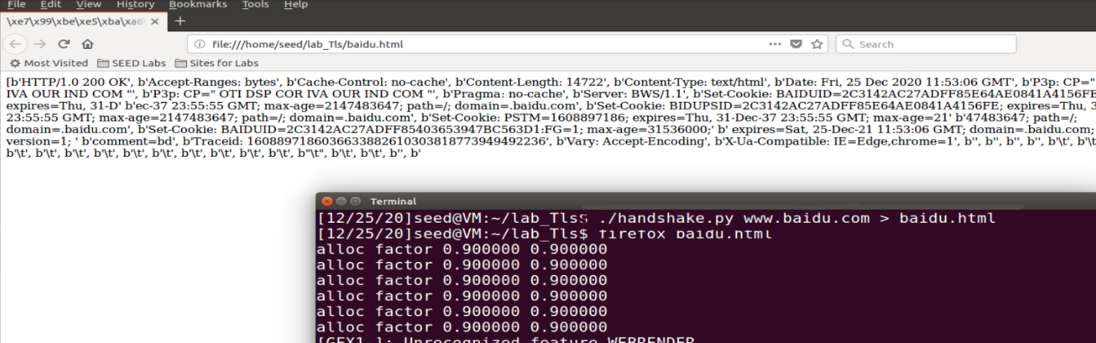

Return the response data to the www.baidu.com website to the baidu.html file and open it with a browser.

(2). Modify the HTTP request line code to make the program return an image file data,...

Will not modify the http request,

I have used it before learning crawlers,

Tried to modify,

But always reporting errors...

I'll make up later...

Make up later...

Make up...

repair…

**Task2:TLS Server**

**task 2.a. Implement a simple TLS server**

This experiment needs to use some files generated in the seedlab Crypto_PKI experiment. In that experiment, we set CN to be the server certificate of SEEDPKILab.com and related files. In this experiment, we will use these files as the certificate of the server program. And send it back to the client program.

Modify the server.py code in the experimental manual as follows:

*#!/usr/bin/python3*

*import socket, ssl, pprint*

*html = """*

*HTTP/1.1 200 OK\r\nContent-Type: text/html\r\n\r\n*

*<!DOCTYPE html><html><body><h1>This is SEEDPKILab.com!</h1></body></html>*

*"""*

*SERVER_CERT = '../lab_pki/server.crt'#seedlab Crypto_PKI The certificate file of SEEDPKILab.com obtained in the experimentSERVER_PRIVATE = '../lab_pki/server.key'#seedlab Crypto_PKIThe private key file of SEEDPKILab.com obtained in the experiment*

*# context = ssl.SSLContext(ssl.PROTOCOL_TLS_SERVER) # For Ubuntu 20.04 VM*

*context = ssl.SSLContext(ssl.PROTOCOL_TLSv1_2) # For Ubuntu 16.04 VM*

*context.load_cert_chain(SERVER_CERT, SERVER_PRIVATE)*

*sock = socket.socket(socket.AF_INET, socket.SOCK_STREAM, 0)*

*sock.bind(('0.0.0.0', 4433))*

*sock.listen(5)*

*while True:*

*newsock, fromaddr = sock.accept()*

*try :*

*ssock = context.wrap_socket(newsock, server_side=True)*

*print("TLS connection established")*

*data = ssock.recv(1024) # Read data over TLS*

*pprint.pprint("Request: {}".format(data))*

*ssock.sendall(html.encode('utf-8')) # Send data over TLS*

*ssock.shutdown(socket.SHUT_RDWR) # Close the TLS connection*

*ssock.close()*

*except Exception:*

*print("TLS connection fails")*

*continue*

**There are a few things to note:**

* In the server.py code, we use sock.bind(('0.0.0.0', 4433)) to bind the listening port 4433, so we need to make some modifications based on the client code in task1, that is, modify the port number (Otherwise the client program and server program will not run successfully):

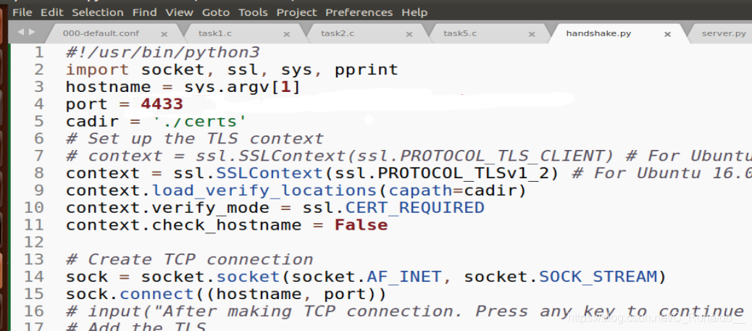

* We need to use SEEDPKILab.com for the host name parameter when running the code on the client, so we need to configure the static IP in the local /etc/hosts file and add the 127.0.0.1 SEEDPKILab.com entry so that the client will access it locally. .
* In the server.py program, the sock.bind(('0.0.0.0', 4433)) code sentence, the IP address of the binding code is 0.0.0.0, which means that for any IP address on the machine, server.py will accept , And then reply to the data, this is very important: it corresponds to the role of the above configuration IP, so that the server and the client program can connect.
* Two Terminals need to be opened, one to run the server.py program and the other to run the client program. The client gets the following results:

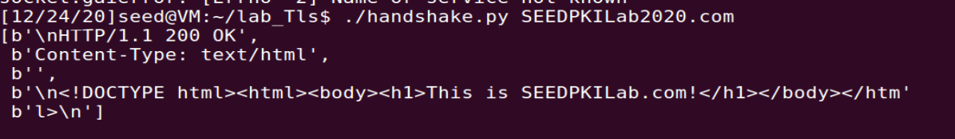

**Linux statements used in the experiment**

In the process of debugging the server.py program, we may encounter the following situations:

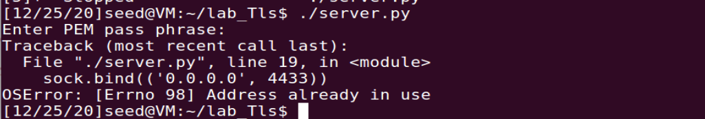

This is a port occupancy problem. Although the server.py program is closed at this time, 0.0.0.0:4433 is still in the listening state. You can use the following statement to close it for subsequent debugging.

*netstat -tunlp*

This is a combined command, -t, -u, -n, -l, -p. It can print out linux network status information, tcp, udp port, IP address and other information, check the 0.0.0.0 in Local Address: 4433 status, if it is running, after getting the corresponding PID, use the following command to kill:

*kill -9 PID (fill in the PID obtained above)*

-9 means forcibly kill the background process.

**Task 2.b. Testing the server program using browsers**

Since in the Crypto_PKI experiment, the root CA certificate created by yourself has been installed in the browser, you can directly test it. After running the server.py program, you will get the following results in the browser:

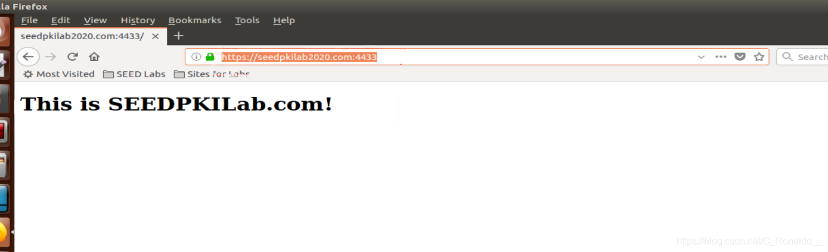

**Task 2.c. Certificate with multiple names**

Configure the server.openssl.cnf file as required, and then use the root CA file ca.crt to sign the certificate with multiple host names according to the experimental manual command, output the server_alt.crt file and the server_alt.key file, and then use these two The file is added to the certification path in the server.py program for testing.

**One thing to note:**

For the req_distinguished_name field information configuration in the server.openssl.cnf file configuration, it is intuitively felt that you can specify it at will, as long as you add the hostname you need in the CN field at the end, but the result is always full of surprises. After randomly filling in an ST field information, the following error message will appear in the command to generate a certificate file:

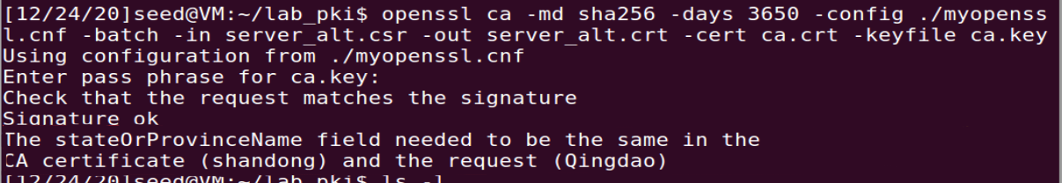

According to the prompt, it needs to be the same as the ST field information in the CA file, set to shandong, why?

Google it and saw a blog written. For a social-oriented CA issuing organization, the country and province in front of the certificate issued by it can be set at will, but when issuing a certificate with a private CA, it needs to be filled in with the server's certificate. The same, otherwise the signing is unsuccessful, and the reason is not said, remember...

Finally, configure server.openssl.cnf as follows:

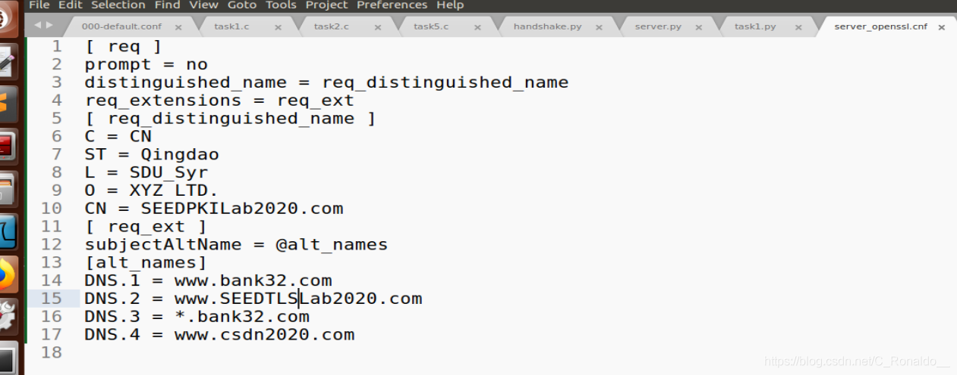

Run the server.py program in one Terminal, and run the client program in task1 in the other Terminal, and use the host name www.csdn2020.com in the alt_name field to access (because it is tested on this machine, it is necessary to configure a static IP in the etc/hosts file , Add 127.0.0.1 www.csdn2020.com entry:

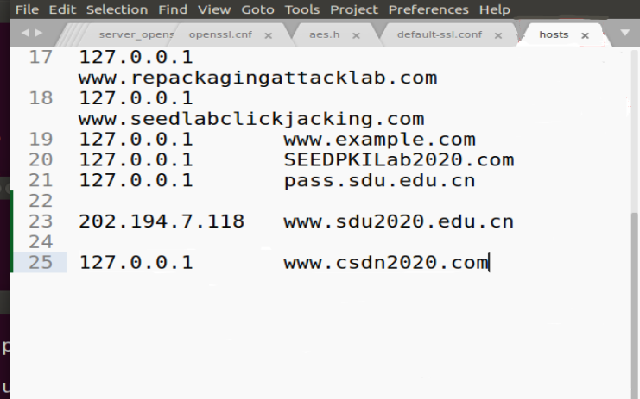

After testing), the following results are obtained:

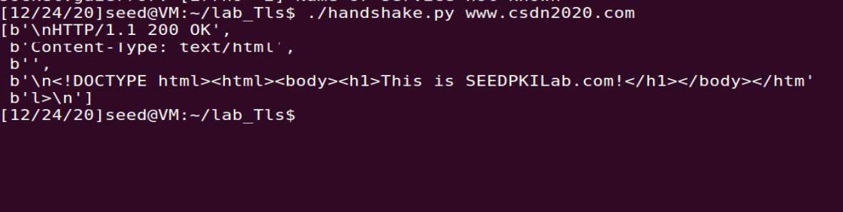

It can also be tested in the browser. Since we have imported the private ca.crt certificate in the browser, and the server certificate we generated is issued by this ca.crt, it will pass the verification:

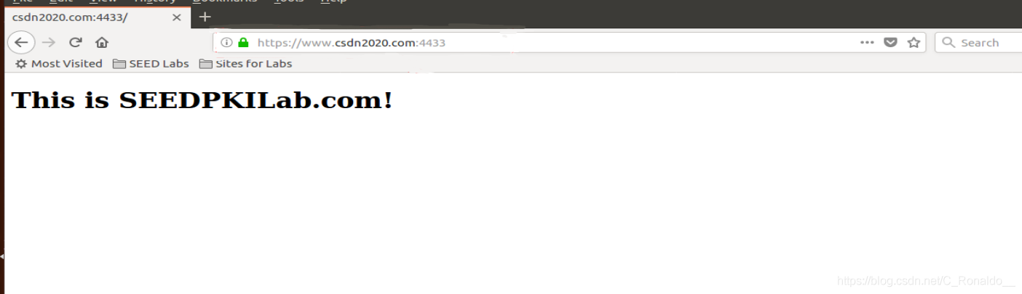

Of course, we can also test on other hosts, just need to configure a static IP in the etc/hosts file to make an IP modification.

**Task3. A Simple HTTPS Proxy**

Encountered a technical problem...

The part of the code that needs to be supplemented is reported

I have too little knowledge of python network ssl programming

Too busy recently

I have to review at the end of the term

In the future, I have time to learn ssl programming systematically

Let's add this part of the experimental report.